/\*Ashok IPBC - Mor.Project R2SP6 Story 10 Lab 8.9.19\*/

Homework:

4. Complete R2:SP6: Story 10 – Create the overall report functionality of the Dashboard. This includes parameters, drill-through’s and subreports. Explain the entire process with explanations, screenshots. While everything doesn’t need to be captured, milestones such as completed queries and reports should be documented.

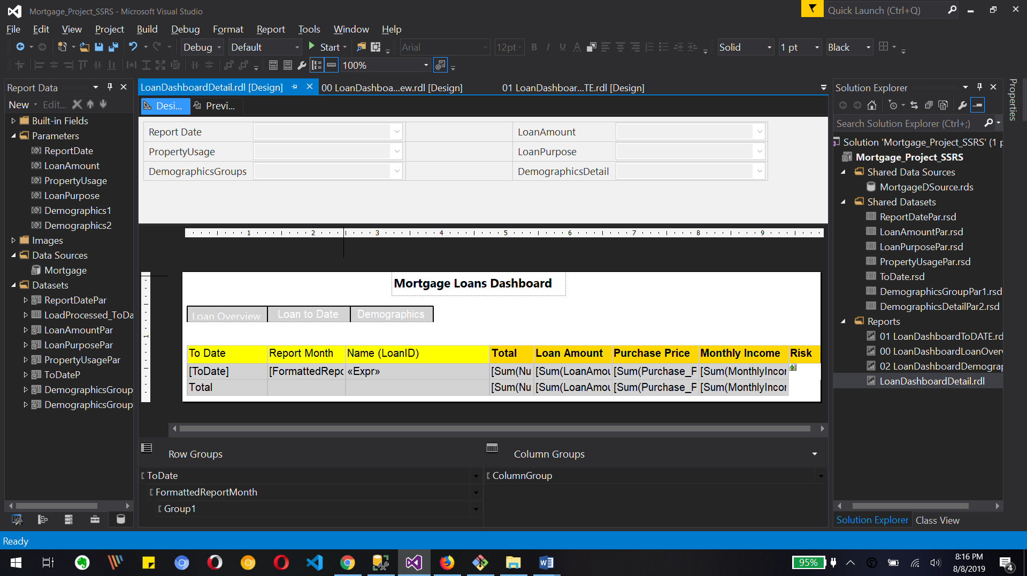

This is a drill down chart which shows loan date, report month, name, total, loan amount, purchase price, monthly income and risk.

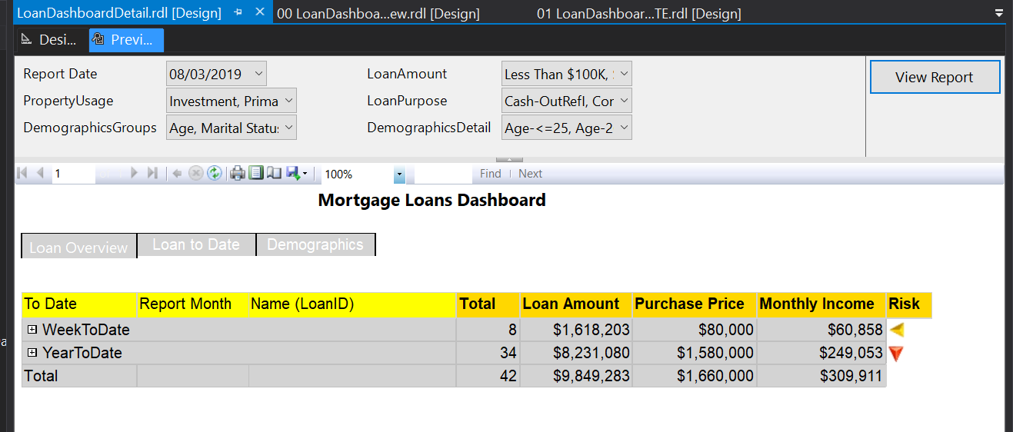

This is the preview of drill down report for Loan detail with default parameters

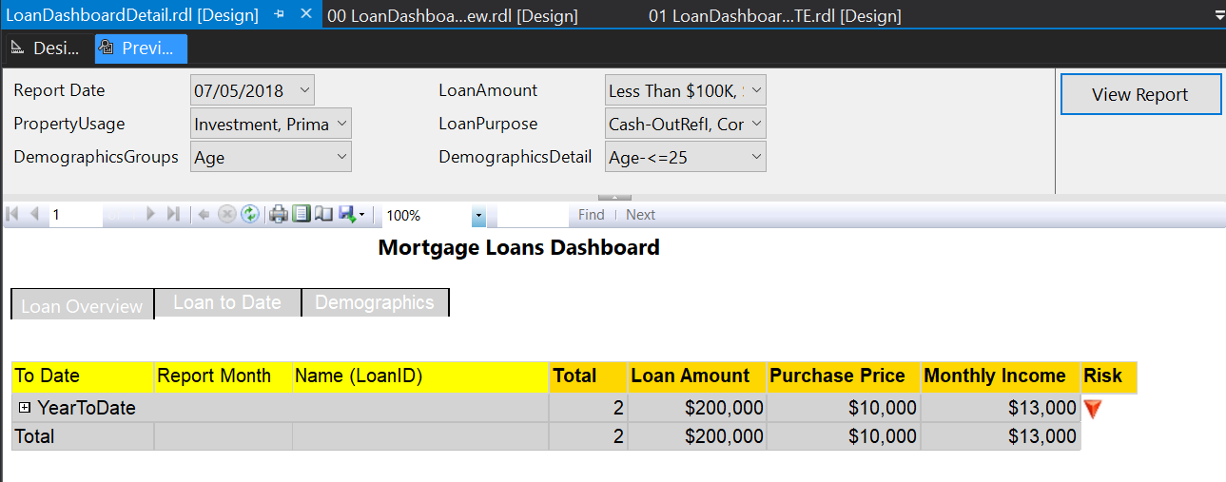

No change the demographic group parameter to age and we see the changing demographics detail and we selected age <= 25

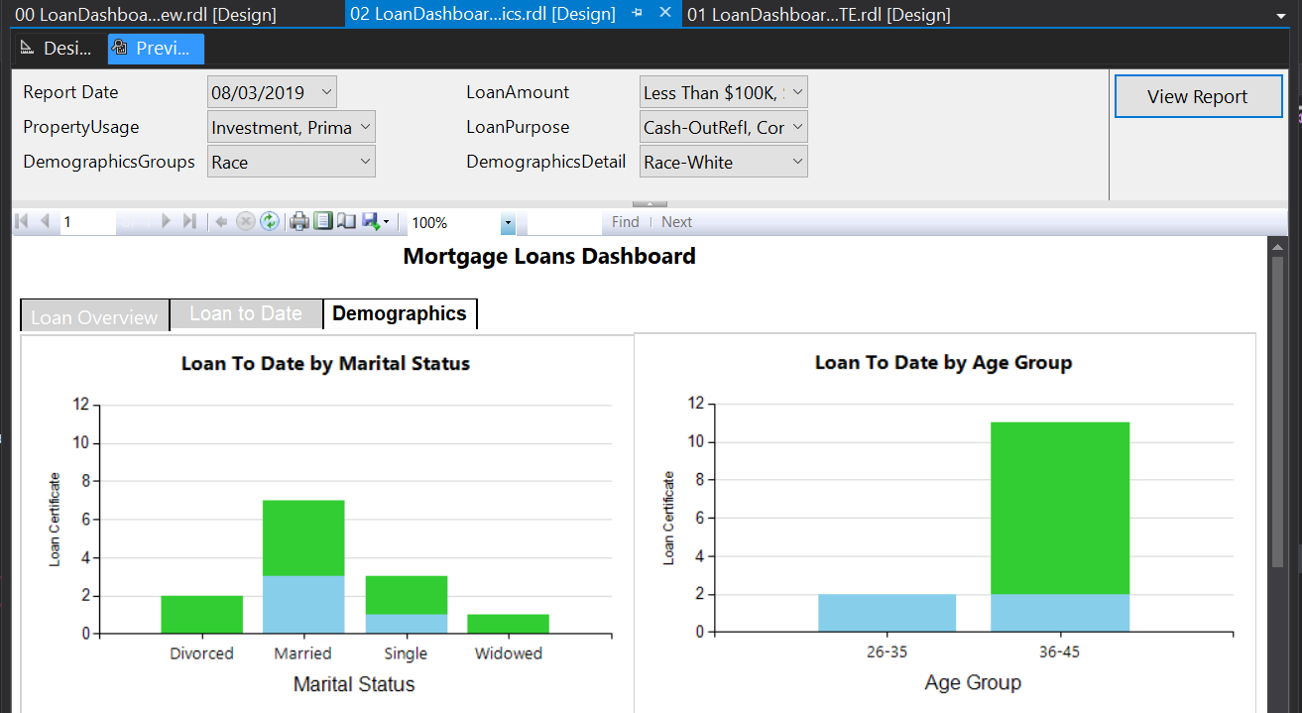

Let's change the demographic group to race and demographics detail to race White and we see the changing demographic loan report from there we will drill down for the parameters by clicking on age group 36-45 bar

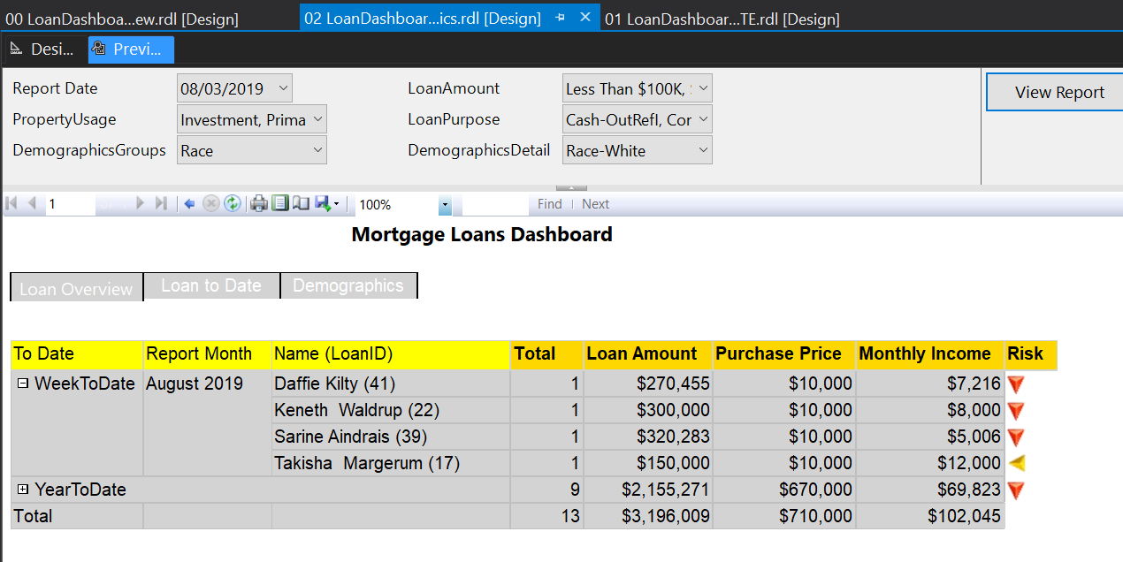

This is drill down for demographics group race and demographics Race White

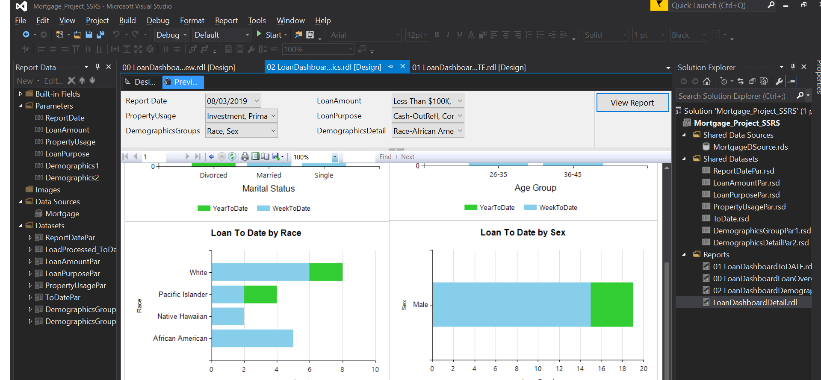

Now let's change race and sex parameter values as  race African American and sex as male

Once we click on bar we will be directed to drill down report for that selection of parameters

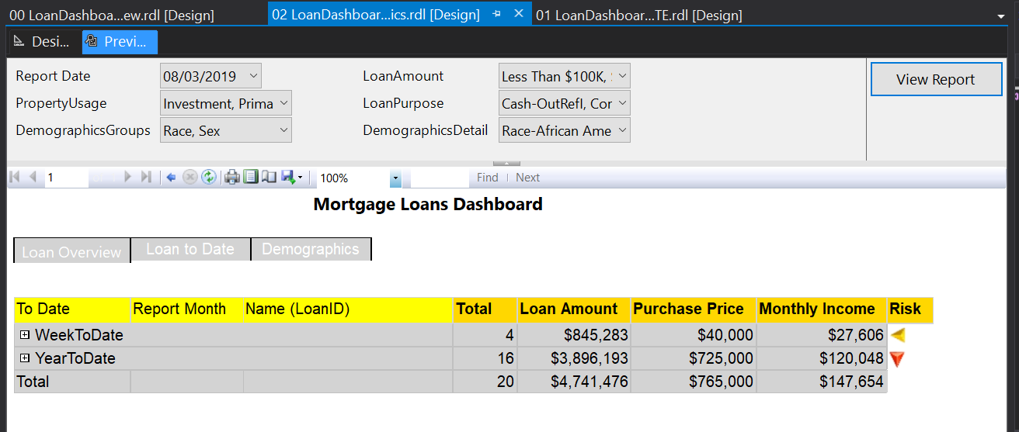

This is drill down report for selected parameters race and sex from our bar chart demographics

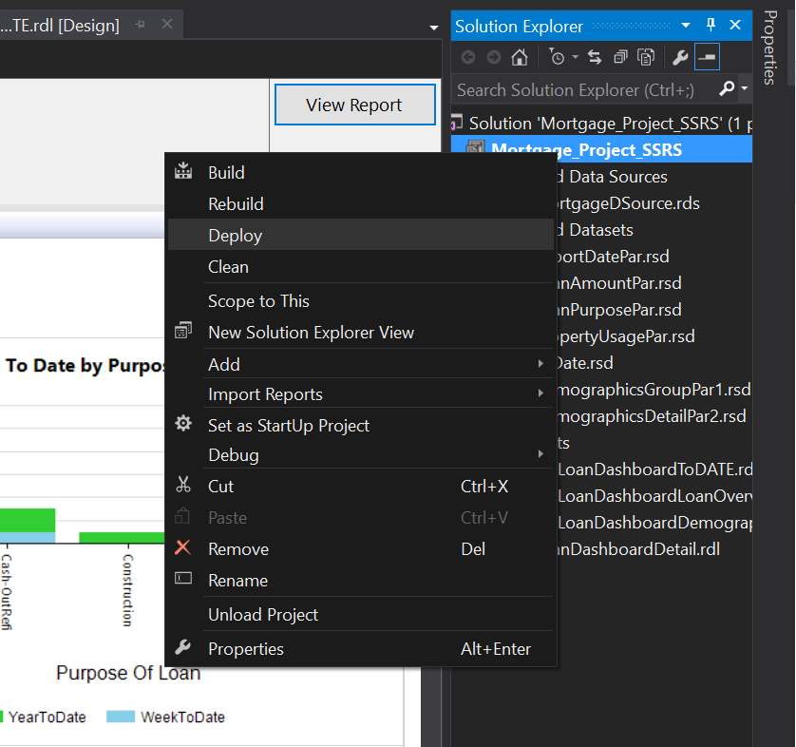

Now we upload report to server with changing property of project and clicking deploy button

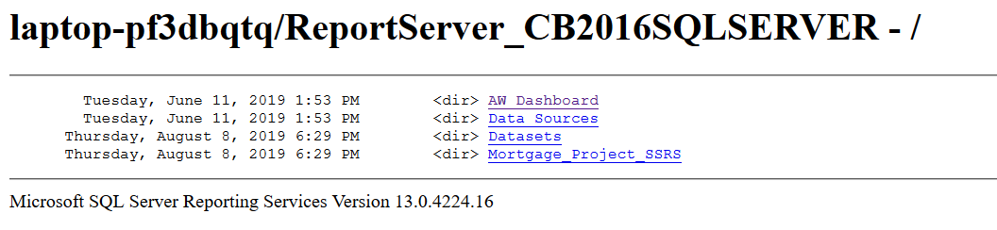

We can see that mortgage project SSRS has been uploaded on server

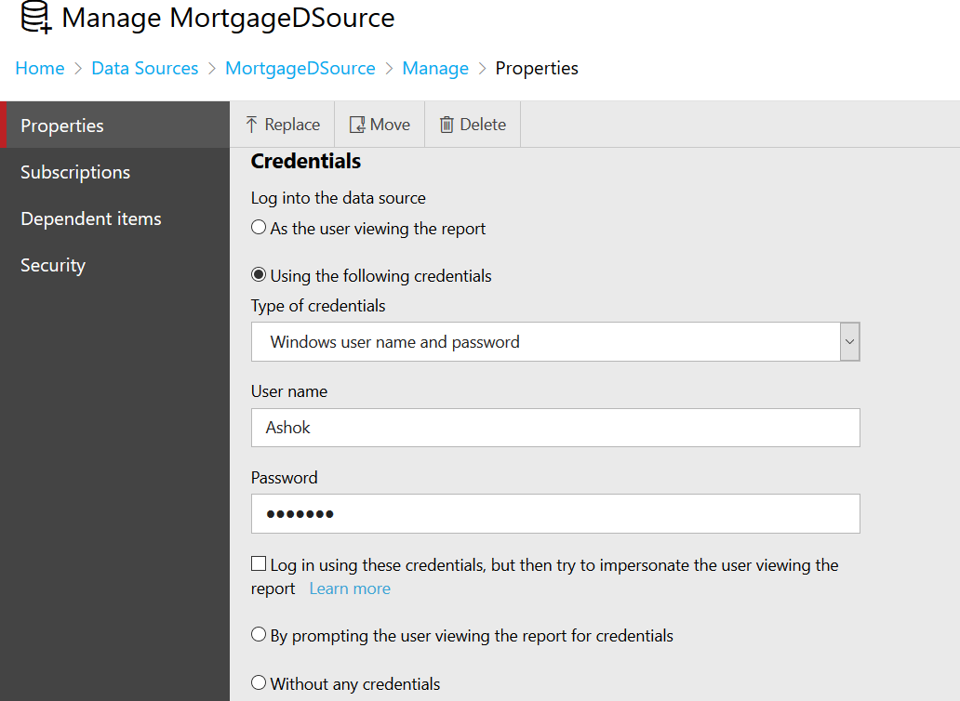

Now let's Jane the credential for our data source so we can create subscription for our reports

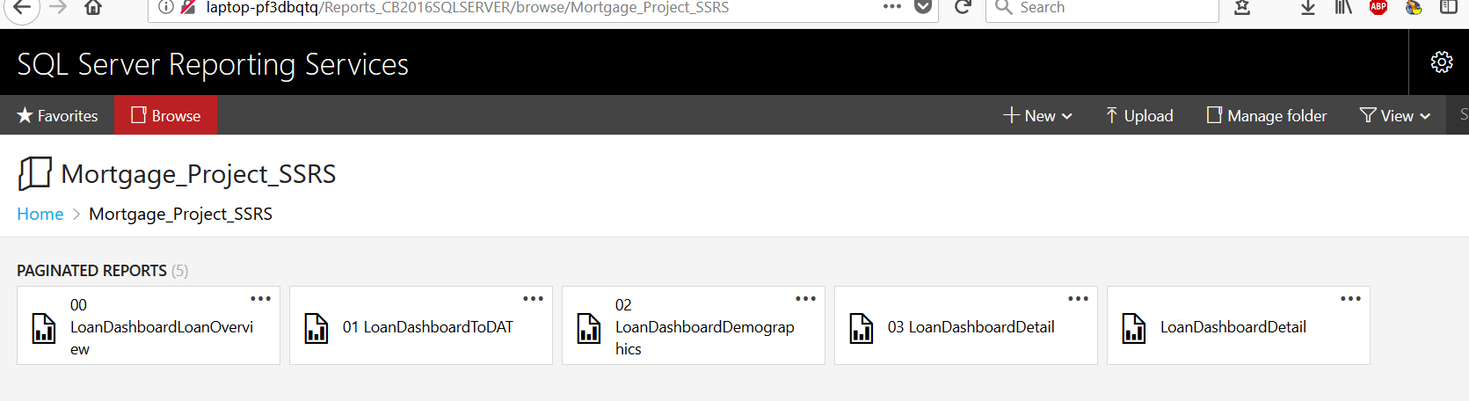

There are total file reports in mortgage project SSRS which are uploaded to server as we can see in the image

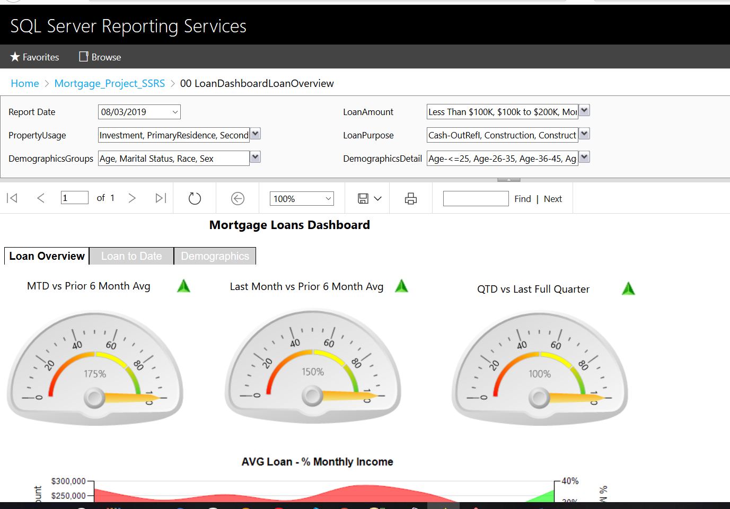

This is loan overview in browser with the default parameters value

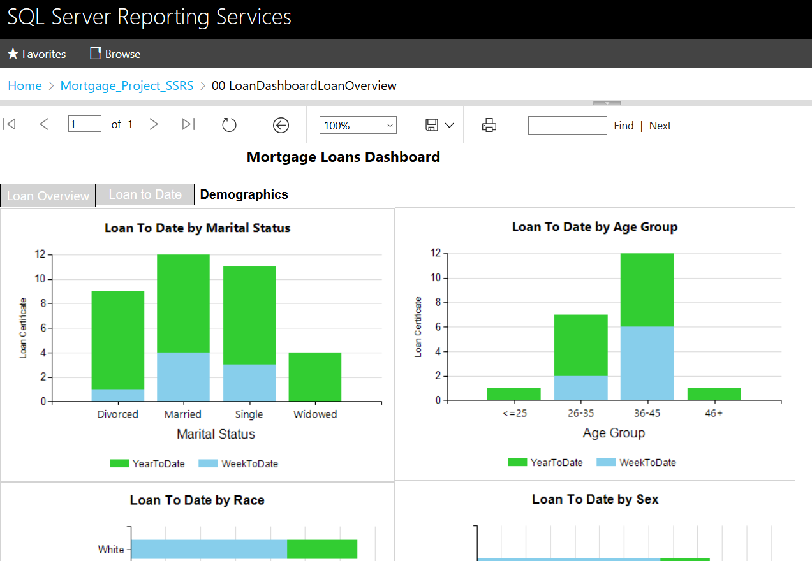

Now we click on a demographics button any browser reporting services we can see demographics charts

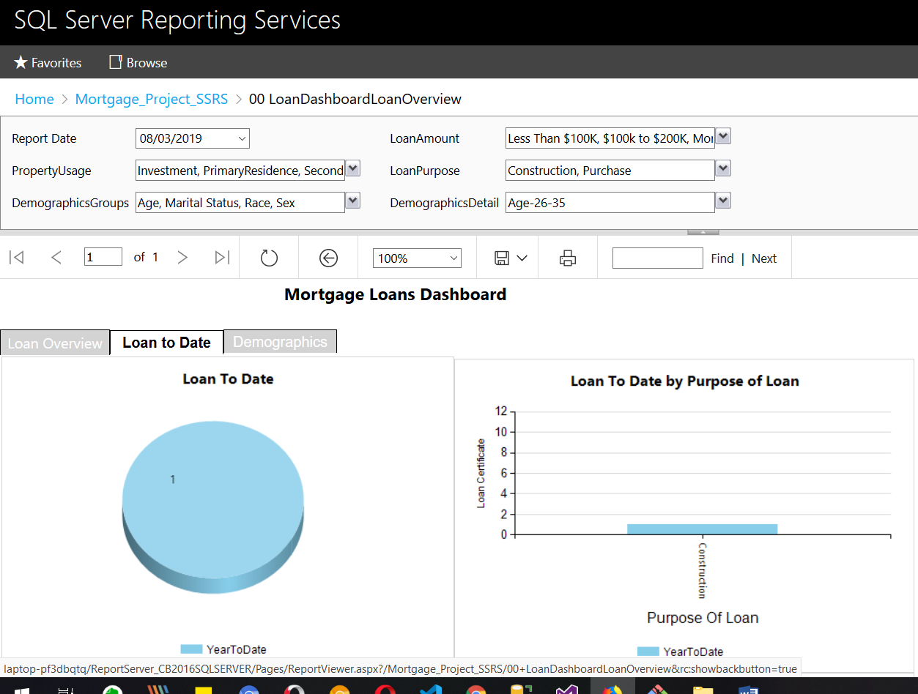

Now we will change our demographic detail parameter 26 to 35 and  we can see the change in report, for Purpose of Loan report we have only one value and we click on it’s bar will direct us to drill down report for it with selected parameters

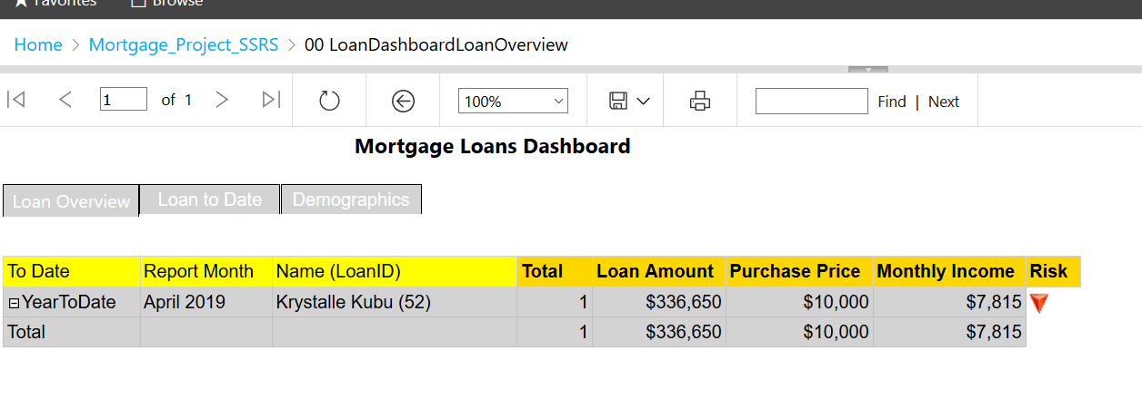

This is drill down report for selected parameters in Purpose of Loan report where we have only one value as Construction purpose. Also we can see risk level direction indicators.

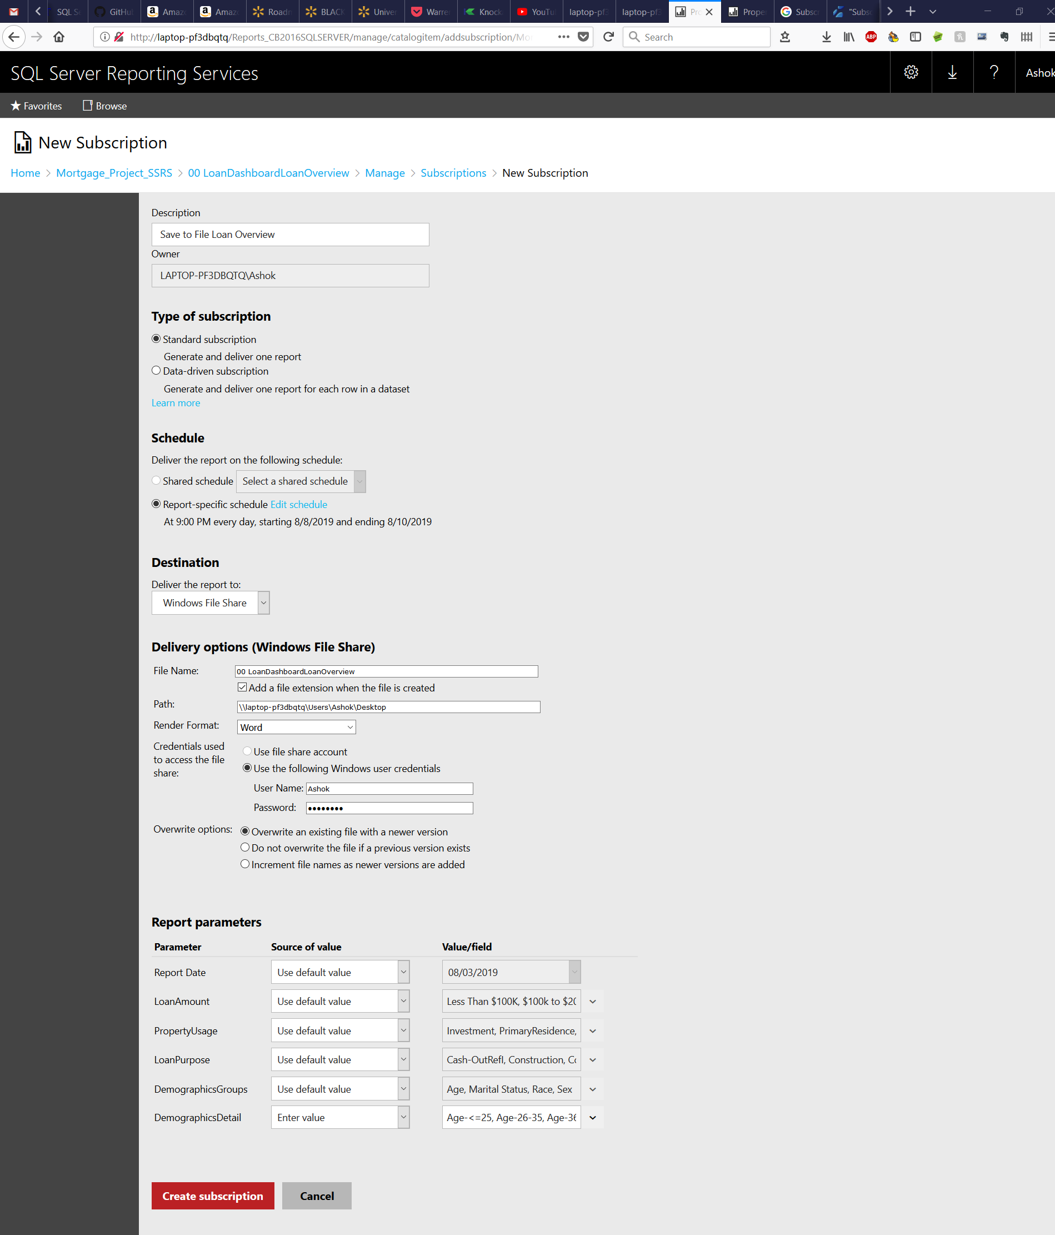

Now we create standard subscription for loan dashboard Loan Overview report with schedule, destination to file, with demographic detail parameter is only for age and credentials for accessing the report

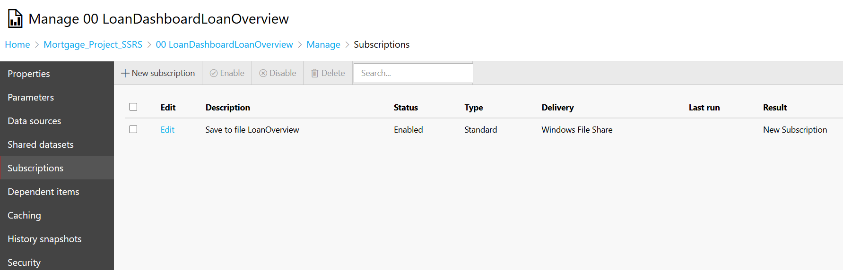

We can see the subscription save to file for loan overview report has been created

What to Submit:

1. Copy and paste the link to your video(s) as part of your homework.

1. IPBC Status Update : Mortgage Project Final

<https://app.colaberry.com/app/ipbc/videos?user=31221&category=16>

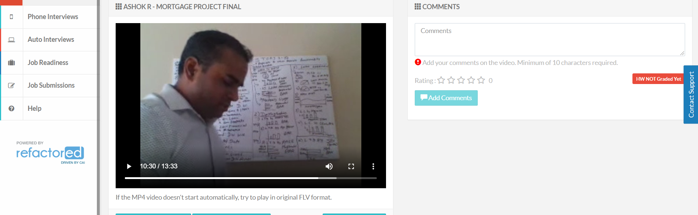

2. SQL BI Interview Questions: SSRS – How do you troubleshoot a report that is running slowly

<https://app.colaberry.com/app/ipbc/videos?user=31221&category=43>

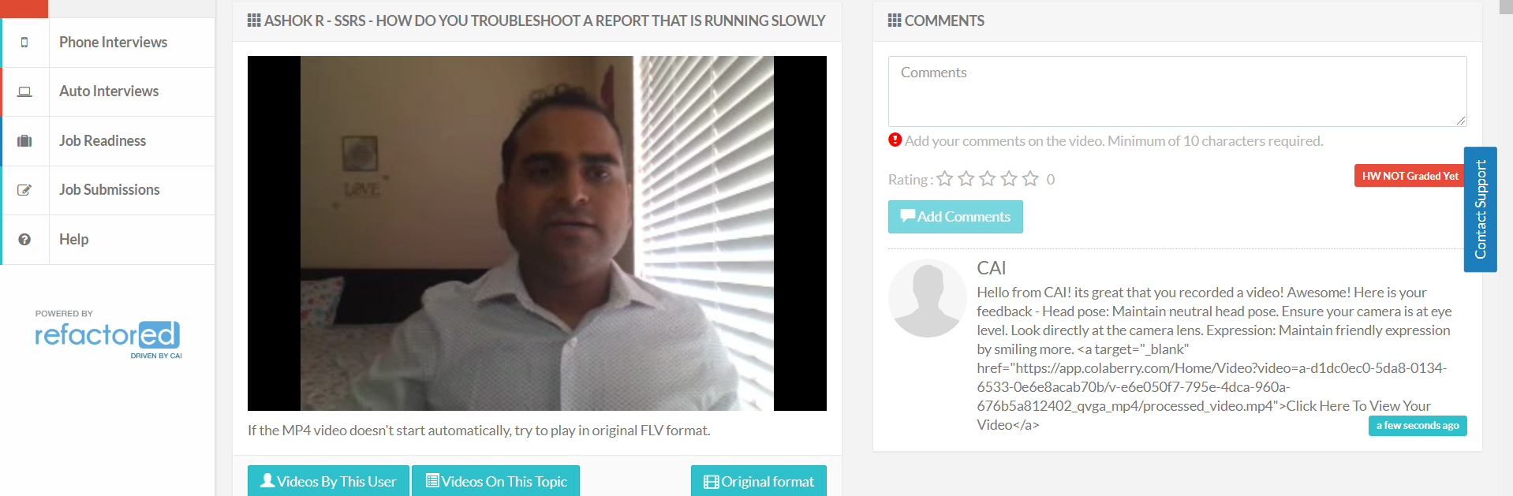

2. Watch, Comment &amp; take screenshots of your comments from 3 other videos on the same

topic (per question). Comments must be 20+ characters. Leave comments based on presentation, delivery and/or technical details. Your critiques will help you be more conscious of your own videos. (3 comment screenshots per Video Question)

1. 1. IPBC Status Update : Mortgage Project Final

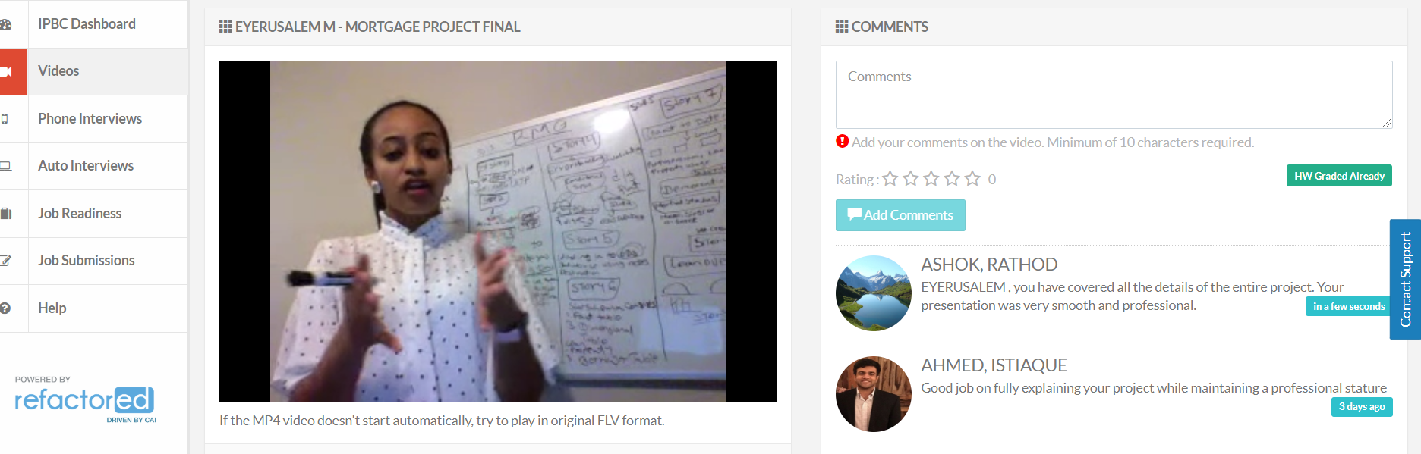

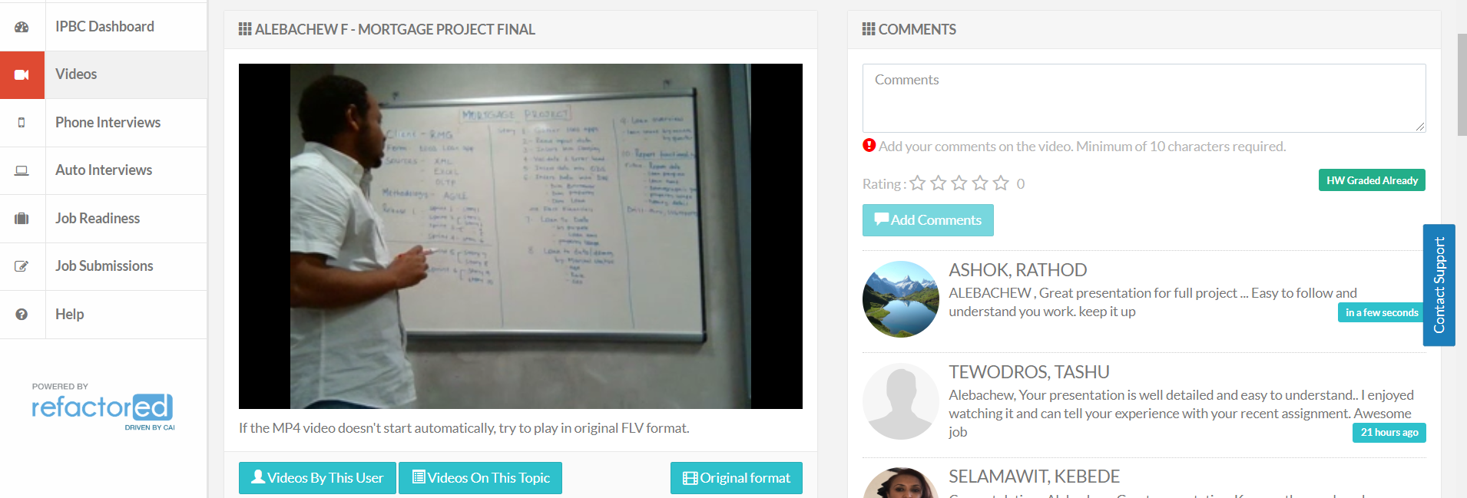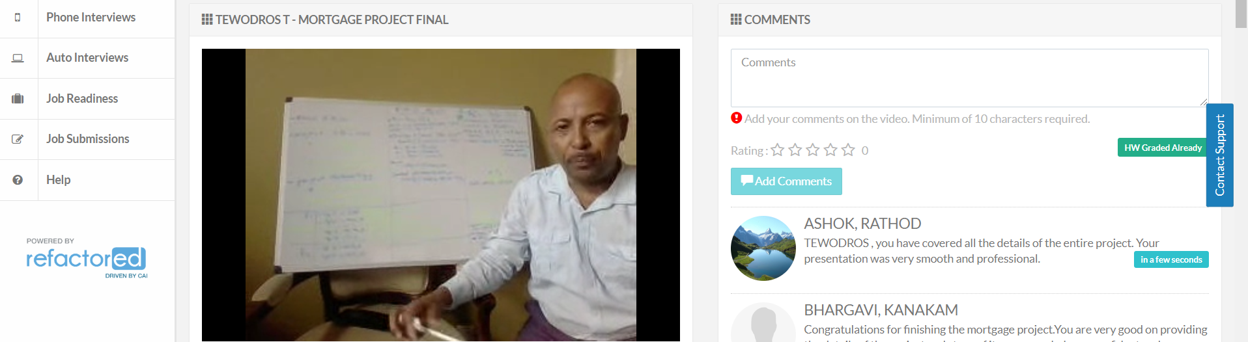

1. 2. SQL BI Interview Questions: SSRS – How do you troubleshoot a report that is running slowly

